GCG 4908 Sales Order Configurator

The 4908 sales order configurator is a custom project for Mercedes Textiles to generate sales order lines and routers for their hoses. There are four main parts, the maintenance program, the Work Order Action Required Program, the purge program, and the configurator itself.

Maintenance

The maintenance program is where the settings and options for the configurator are maintained. The menu item is located at Order Entry > Administration > Configurator Maintenance.

The coupling tab is where the coupling information, the cover and slot types are entered. A key identifier and description/name must be entered for each one. Clicking save will add it to the list, while clicking delete will remove it. These will be the options in the slot and column sections of the configurator.

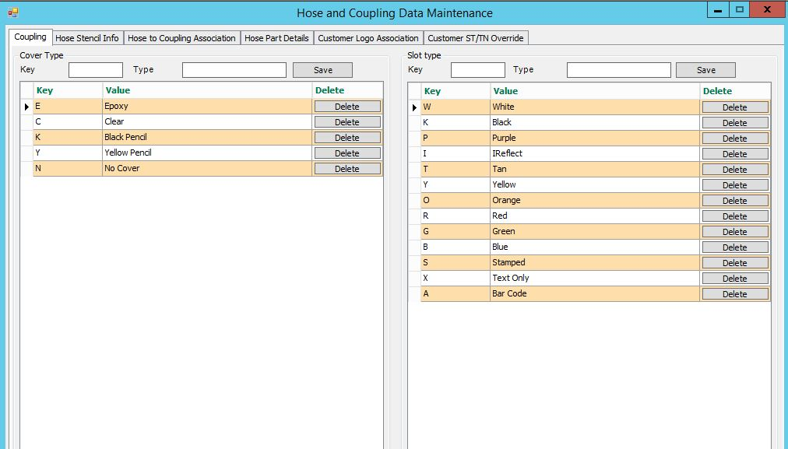

The Hose Stencil Info tab is where the approval types, brand logos, and service test and trade name information is entered. The Approval will be selectable in the approval field of the configurator. The Brand Logo section is for associating a logo file to brand names which can be used in for customer logo associations or selected in the logo drop downs on the configurator. Service test and trade name on the configurator will populate based on the class, diameter, and assembly entered in the service test and trade name section. The information on the class and diameter drop downs is maintained in the Hose Part Details tab.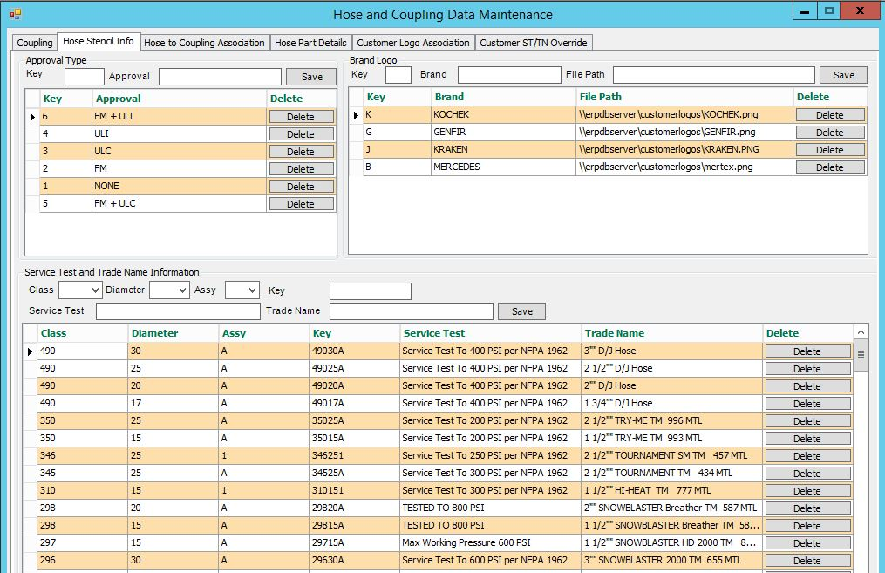

In the Hose To Coupling association tab, the different hose and coupling combinations are set. The grid on the left is for entering hose types, as a class, diameter, and hose bowl combination. The list of Hose Bowls comes from the 7th and 8th character in all parts with the product line CP. The grid on the right is for associating / enabling different coupling types for these hoses. Click on a hose record to bring up it’s coupling list and choose which are enabled for that hose. The information in the class and diameter drop downs is maintained in the Hose Part details tab.

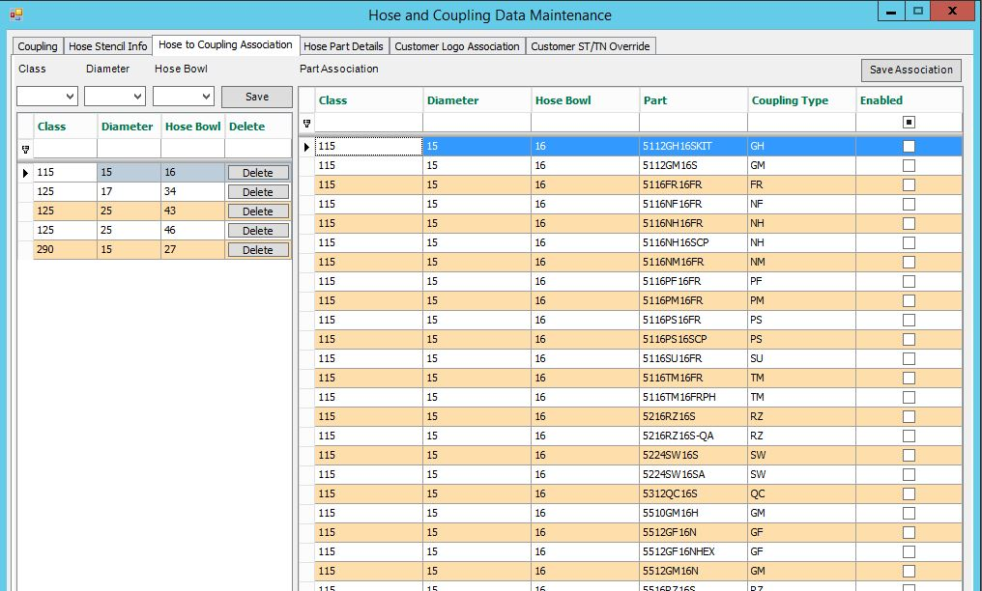

In the Hose Part Details tab, the hose information is entered. This is where the difference classes are defined, as well as the different color, length, and diameter possibilities. In the class grid, the description of each class is set along with whether or not it has a pinfold.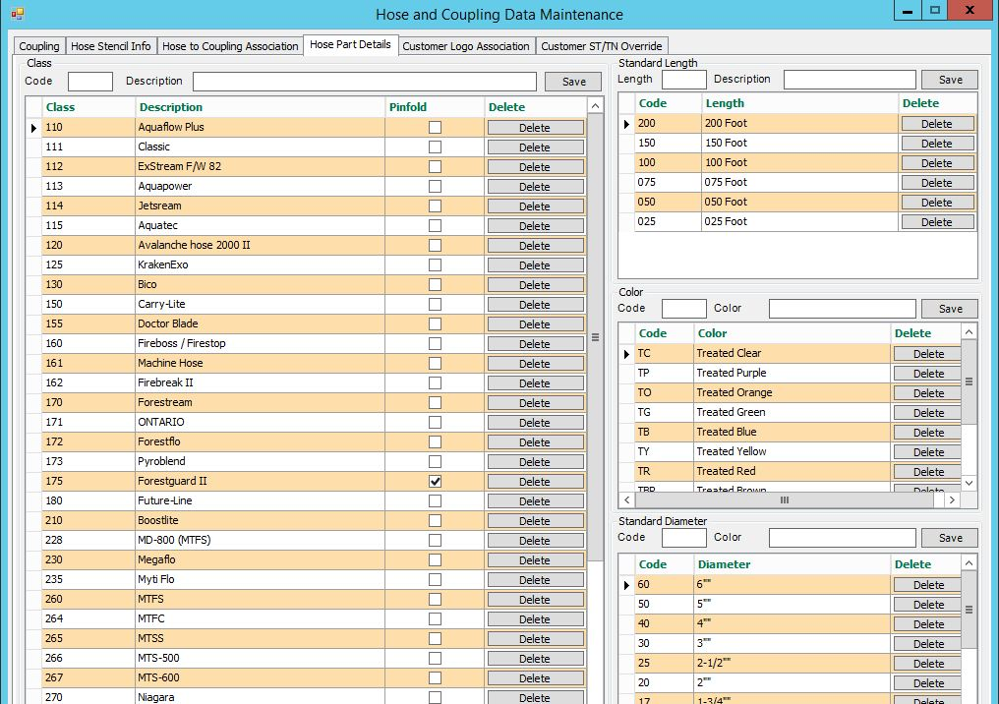

The customer logo association tab is where different logos can be set for different Customer/class combinations. When the logos are loading in the configurator, first the customer/class combination will be checked. If there is no logo for that, the customer’s primary logo will be used. Any additional logos for that customer will be listed in the dropdowns. The MERCEDES logo is always available to be chosen, and is the default.

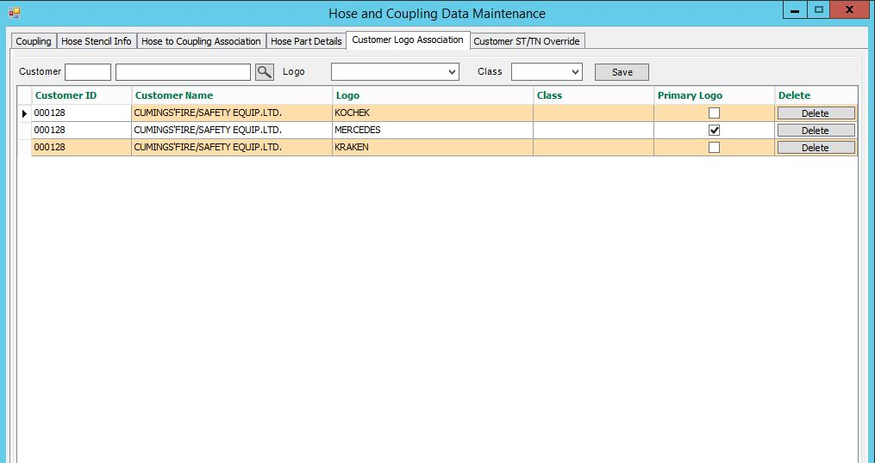

In the customer ST/TN Override tab, override service test and trade name information can be entered for certain customer or customer/class combinations. If an entry here exists for what is selected in the configurator, this information will be used instead of the normal class service test and trade name.

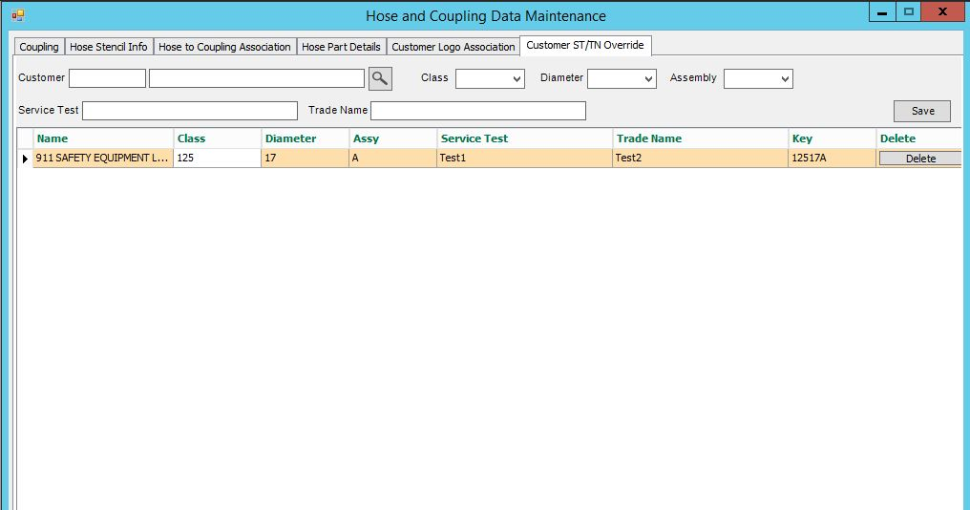

Configurator

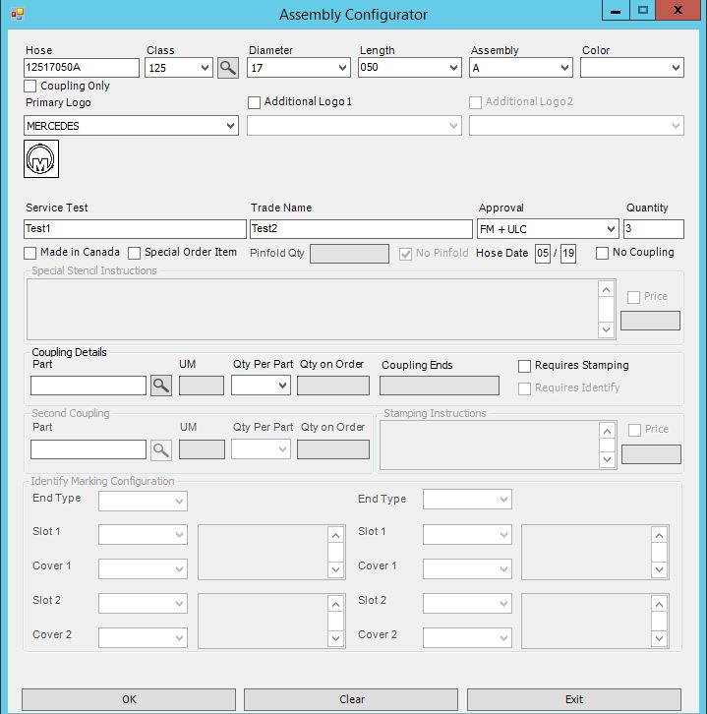

The sales order configurator can be accessed through the script 1 button on the sales order lines screen. Here hoses and couplings can be configured and added to the sales order.

The hose can be typed in manually or built by selecting from the different drop downs. When the hose is complete the logo, service test, and trade name information will load depending on what’s in the maintenance program. The class, diameter, length, color, slot, and cover drop downs come from the maintenance program as well.

To add just a hose or just a coupling, the Coupling Only or No Coupling checkboxes can be checked.

The hose date fields will load the next month, but can be modified manually.

Special stencil instructions can be added if the Special order Item check box is checked, and stamping instructions for the hose can be added if the Requires Stamping check box is checked. Couplings can be selected in the coupling browsers or entered manually, and are selected from parts with the CP product line. Depending on the UM and Qty Per Part entered, a second coupling can be selected. (Two couplings per hose, so if UM = EA and Qty Per = 1 you can select a second coupling, or if UM = ST for set and Qty Per = 0.5 a second coupling can be selected.

The Identify checkbox will be enabled if the coupling has the sort code WO or IDF, and checking it will determine if the Identify frame is enabled. If so, the different slot/cover combinations can be chosen and bar coding or text added in the text boxes.

The pinfold field will be enables based on if the class is set to use pinfolds in the maintenance program.

If the price checkboxes by the Stenciling/Stamping instructions are used, this price will be added to the price of the customizations.

When okay is clicked, the chosen couplings and hoses will be added to the sales order, as well as a non-inventory part for the customizations. A router will be built for this non-inventory part based on the selections.

Router Generation:

The router will be built from a template router based on the class, diameter, if there is a pinfold, and if there is a coupling. The format will be \*[CLASS][DIAM][F][CPL+TST], so an example for the hose above is \*125050CPL+TST. The structure and entries of this router will be used for the created router.

The created router number will be Z[HOSE][COUPLING 1 THREADING][COUPLING 2 THREADING][COUNTER]. The threading is the 5th and 6th characters of the coupling part. An example for the hose above is Z125FBCPL+TST.

When generating the new router, an IDF step will be added (if there isn’t one already) if there is Identify details or special stamping instructions.

The information from the configurator will be added as comments and comment lines to the router.

Purge

The purge program is located at Order Entry > Administration > Configurator Purge. When run, the screen will launch, and the user can choose to whether or not to purge both routers and saved screens. When run, the purge will delete any routers starting with Z that do not have associated open sales orders.

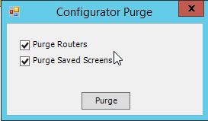

Work Order Action Required

The work order action required program will check when an order or order line is delete if there are any open work orders tied to it. If there are, the user will be notified of it and an email will be sent to everyone in the 4908 security group. The work order will also be added to a list, which can be viewed in Order Entry > Administration > Deleted SO/WO Action Required. From there the information can be viewed, the work order can be opened, or delete.

